Sri Lanka Institute of Information Technology



B.Sc. (Hons) in Information Technology

Specializing in Cyber Security

Year 2, Semester 2

**IE2062: Web Security**

Week 1 Submission – PortSwigger Labs - XSS

IT23714120

A.M.M.G.K.P. Athawuda

Contents

1 Introduction 3

2 Lab 1: Reflected XSS into HTML context with nothing encoded 3

3 Lab 2: Stored XSS into HTML context with nothing encoded 6

4 Lab 3: DOM XSS in document.write sink using source location.search 9

5 Lab 4: DOM XSS in innerHTML sink using source location.search 12

6 Lab 5: DOM XSS in jQuery anchor href attribute sink using location.search source 14

7 Lab 6: DOM XSS in jQuery selector sink using a hashchange event 15

8 Lab 7: Reflected XSS into attribute with angle brackets HTML-encoded 17

9 Lab 8: Stored XSS into anchor *href* attribute with double quotes HTML-encoded 18

10 Lab 9: Reflected XSS into a JavaScript string with angle brackets HTML encoded 20

# Introduction

**XSS** is a Cross-Site Scripting, which is a client-side code injection attack where malicious JavaScript is injected into a web page viewed by other users.

Main types of XSS are:

1. Reflected XSS

Script is injected into a request and reflected immediately in the response.

1. Stored XSS

Script is stored on the server and served to multiple users.

1. DOM- based XSS

The injection occurs via client-side JavaScript without server-side modification.

# Lab 1: Reflected XSS into HTML context with nothing encoded

The instruction for the lab says that there is a vulnerability in search functionality. And to solve the lab it must perform a cross-site scripting attack that calls the ‘alert’ function.

**Solution:**

1. **Click Access the lab and go to the new site provided.** 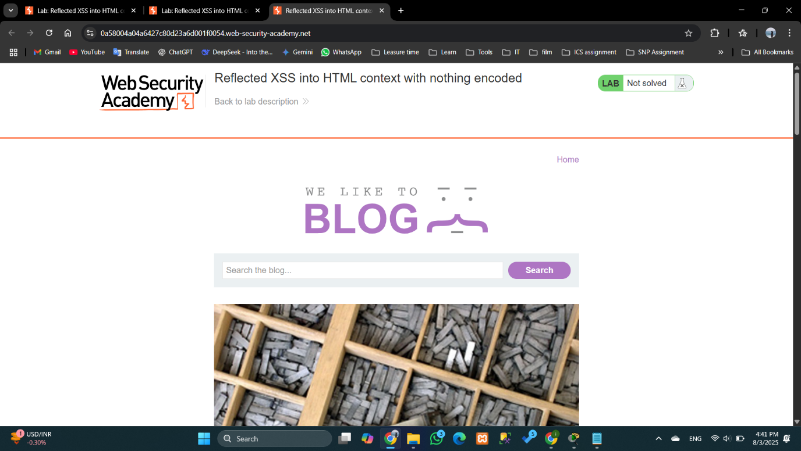
2. In the search box or in the URL type something to how that text appeared.

1. Type various kinds of inputs in the search box to see what happened. When type a html tag or js code it rendered the output.

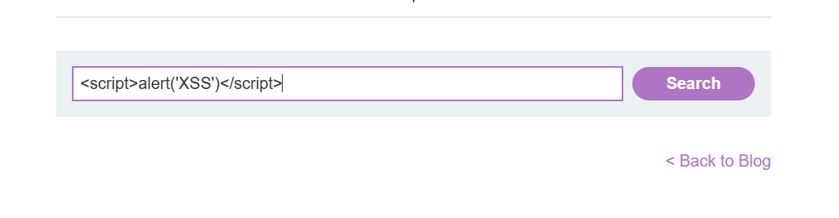

1. When JavaScript code entered an alert box popped up. It executes Js input without any encoding.

* It demonstrates that the website is vulnerable to reflected XSS attacks as it

# Lab 2: Stored XSS into HTML context with nothing encoded

**Instruction**:

**Solution**:

1. There are some blogs on the site and to go to comment section by clicking ‘view post’.

1. Then post a comment in plain text and use HTML to see what happened.

Html:

1. Enter a JavaScript payload:

1. Alert executes. It means the site is vulnerable to all users who view the comment, and the output is not encoded when displaying comments.



# Lab 3: DOM XSS in document.write sink using source location.search

**Instruction**:

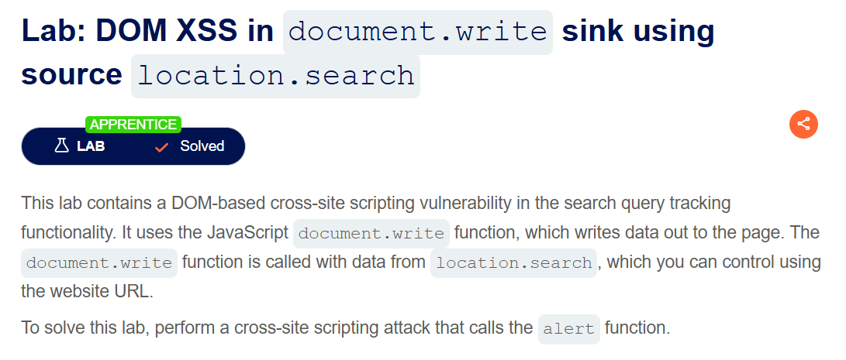

**Solution**:

1. Access the lab and open the ‘inspect’ the page.
2. Enter a test string like ‘Hello’ and see what happens in the code.

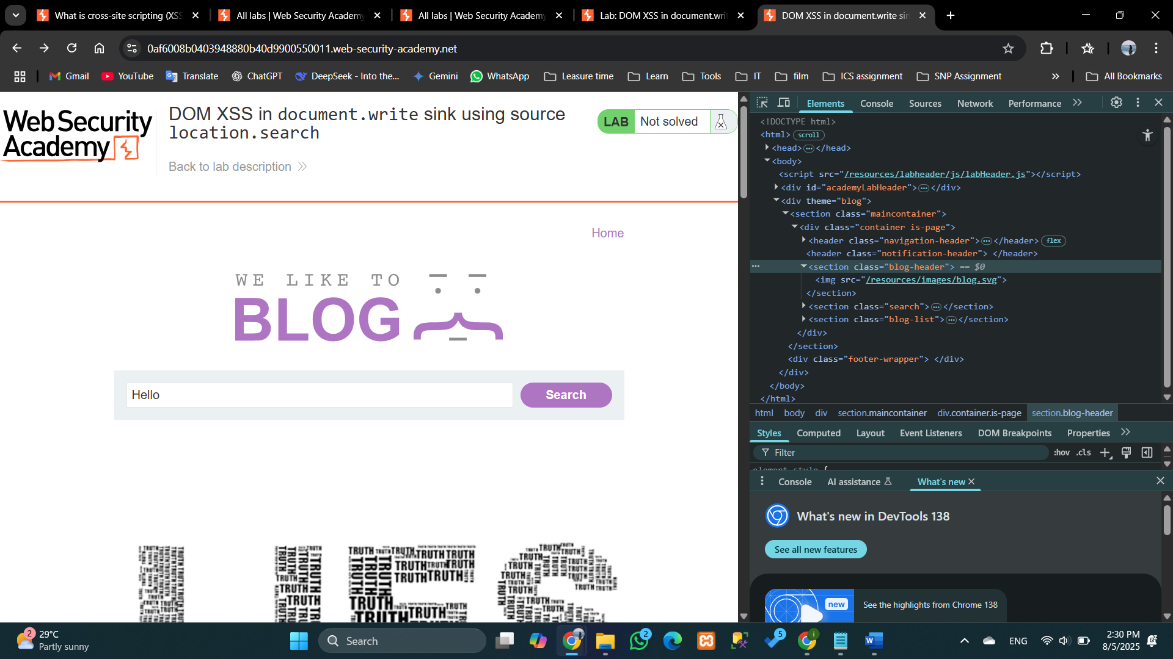

1. The string that entered appeared in ‘src’ attribute ‘<img>’ tag.

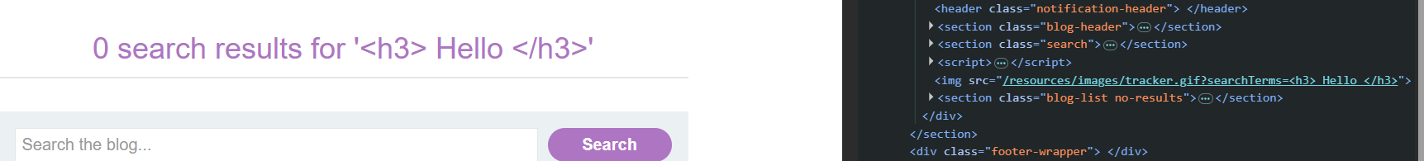



1. This indicates the application dynamically writes search terms into the DOM using ‘*document*.*write’*.
2. To break down that html attribute and enter JavaScript enter the below payload:

( “ closes the src attribute and > closes img tagged )

# Lab 4: DOM XSS in innerHTML sink using source location.search

**Instruction:**

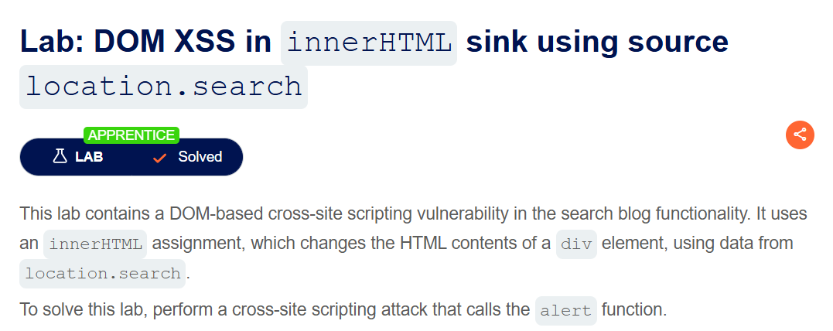

**Solution**:

Search <h3> Hello </h3>

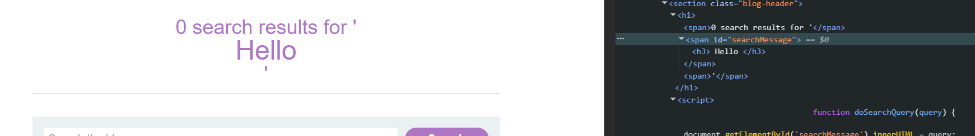

<script>alert('Lab’) </script>

[to force an error: - src(1); invalid source , an onerror event handler containing the malicious JavaScript]

Popup is appearing. The page is vulnerable.



# Lab 5: DOM XSS in jQuery anchor href attribute sink using location.search source

**Instruction:**

**Solution**:

1. Navigate to submit feedback page.
2. The URL:



Inspect the page:

1. Modify the URL to:



1. ‘Return path’ parameter controls the back links destination, and it directly updates the href tag.
2. Since href accepts JavaScript; enter the payload:



# Lab 6: DOM XSS in jQuery selector sink using a hashchange event

**Instruction:**

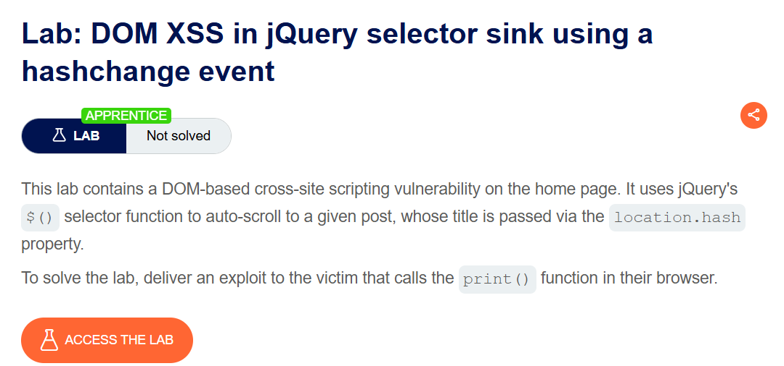

**Solution**:

1. Access the lab and see where the jQuery selector exists.

1. go to the exploit server and paste the payload.

Click ‘view exploit’.

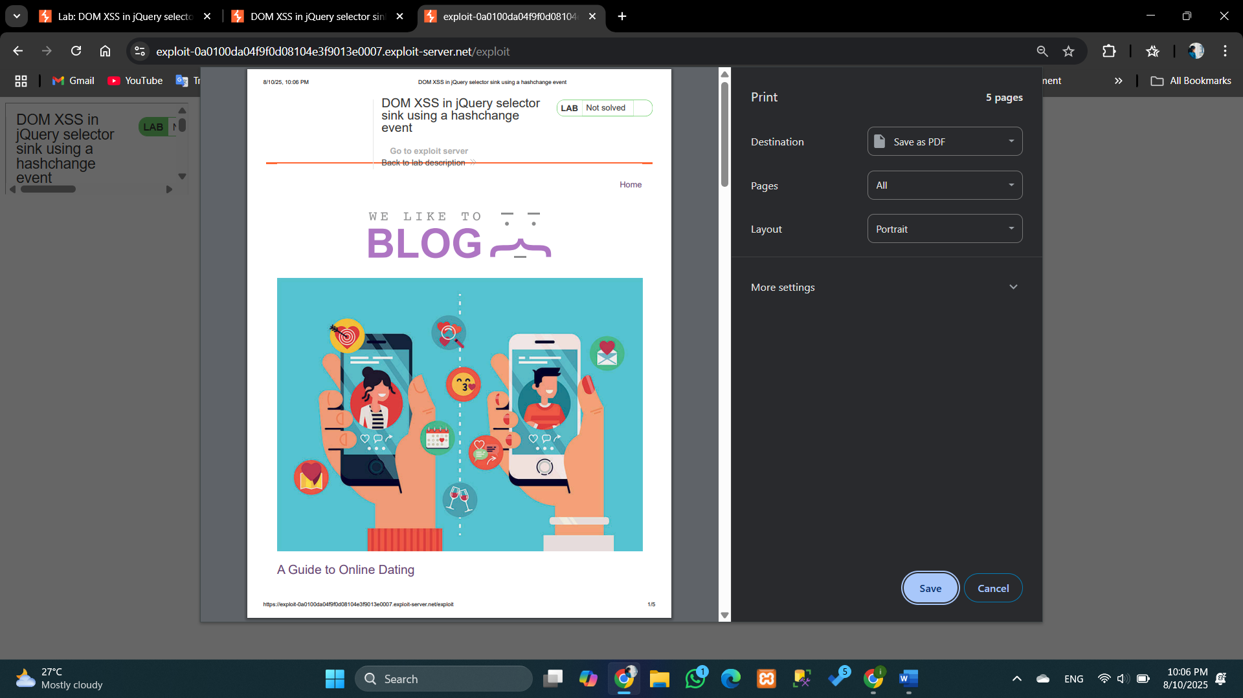

And then click ‘Deliver exploit to victim’. Then the lab will be solved.

# Lab 7: Reflected XSS into attribute with angle brackets HTML-encoded

**Instruction:**

**Solution**:

1. To see is the angle brackets are encoded in the search functionality search something in the search bar.

1. In the source code the brackets are encoded with < = &it and > = &gt.

1. Insert a malicious payload:

1. When we move the mouse over the search bar. it pops up an alert.

# Lab 8: Stored XSS into anchor *href* attribute with double quotes HTML-encoded

**Instruction:**

**Solution**:

# Lab 9: Reflected XSS into a JavaScript string with angle brackets HTML encoded

**Instruction:**

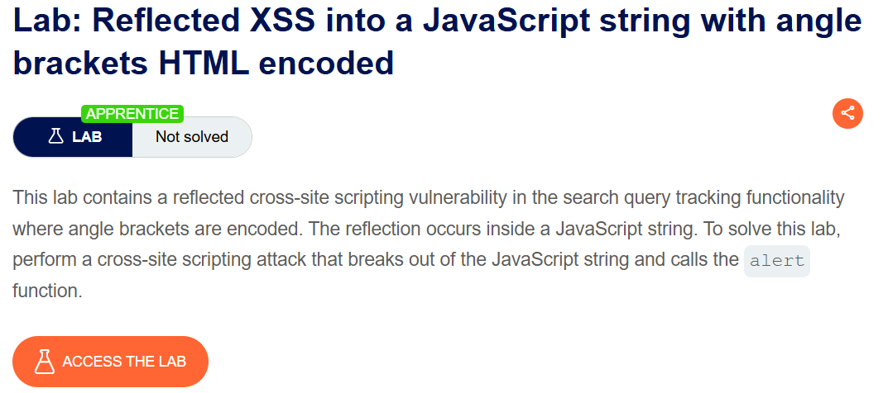

**Solution**:

In this lab angle brackets (>, <) are html encoded as &gt and &lt. but the other symbols (/, “) are not encoded.

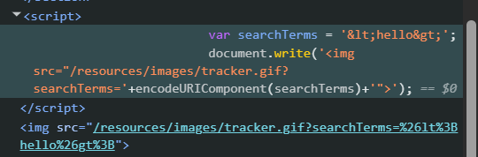

So we can use a single command to inject malicious code.

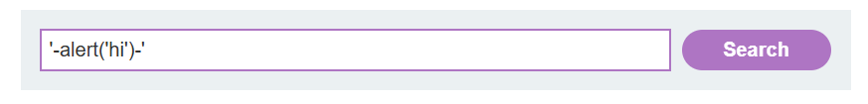

Pop up appeared.

